HEALTH AND SAFETY POLICY

1.General Statement of Policy

This document is the Health and Safety Policy of Over Haddon Village Hall Management Committee.

Our policy is to:
a) Provide healthy and safe working conditions, equipment and systems of work for our employee(s), volunteers, committee members and hirers
b) Keep the village hall and equipment in a safe condition for all users
c) Provide such training and information as is necessary to staff, volunteers and users.

It is the intention of Over Haddon Village Hall Management Committee to comply
with all health and safety legislation and to act positively where it can reasonably do so to prevent injury, ill health or any danger arising from its activities and operations.

Over Haddon Village Hall Management Committee considers the promotion of the health and safety of its employees at work and those who use its premises, including contractors who may work there, to be of great importance.
The management committee recognises that the effective prevention of accidents depends as much on a committed attitude of mind to safety as on the operation and maintenance of equipment and safe systems of work.
To this end, it will seek to encourage employees, committee members and users to engage in the establishment and observance of safe working practices.
Employees, hirers and visitors will be expected to recognise that there is a duty on them to comply with the practices set out by the committee, with all safety requirements set out in the hiring agreement and with safety notices on the premises and to accept responsibility to do everything they can to prevent injury to themselves or others.

Signed: (On behalf of the Management Committee):

Name: ……………………….
Position: Chair Date: 21/7/2019
Review Date: Second meeting after the next AGM.

2.Organisation of Health and Safety
The Over Haddon Village Hall Management Committee has overall responsibility for health and safety at Over Haddon Village Hall.

The person (s) delegated by the management committee to have day to day responsibility for the implementation of this policy is/are:
Name: Jen Foxon
Telephone No: 01629 812133
Address: South View, Main Street, Over Haddon, Bakewell DE45 1JE
Name: Zena Hawley
Telephone No: 01629 814750
Address: Rose Cottage, Over Haddon, Bakewell DE45 1JE

It is the duty of all employees, hirers and visitors to take care of themselves and others who may be affected by their activities and to co-operate with the management committee in keeping the premises safe and healthy, including the grounds.
Should anyone using the hall come across a fault, damage or other situation which might cause injury and cannot be rectified immediately they should inform the person above, or the Bookings Secretary, as soon as possible so that the problem can be dealt with.
Where equipment is damaged a notice should be placed on it warning that it is not to be used and it should be placed in the storeroom.

The following persons have responsibility for specific items:

First Aid box: Helen Head.
Reporting of accidents: Jen Foxon, Zena Hawley.
Fire precautions and checks: Jen Foxon, Trish Renshaw, Roger Truscott.
Training in use of hazardous substances and equipment: Jen Foxon.
Risk assessment and inspections: Jen Foxon, Zena Hawley
Information to contractors: Zena Hawley, Martin Chresta
Information to hirers: Jen Foxon.
Insurance: Zena Hawley

A plan of the hall is attached showing the location of fire exits, fire extinguishers, plant room (which houses the fuse box, water stop cock, hot water storage cylinder, air source heat pump inlets and solar panel converter units), loft access and office.

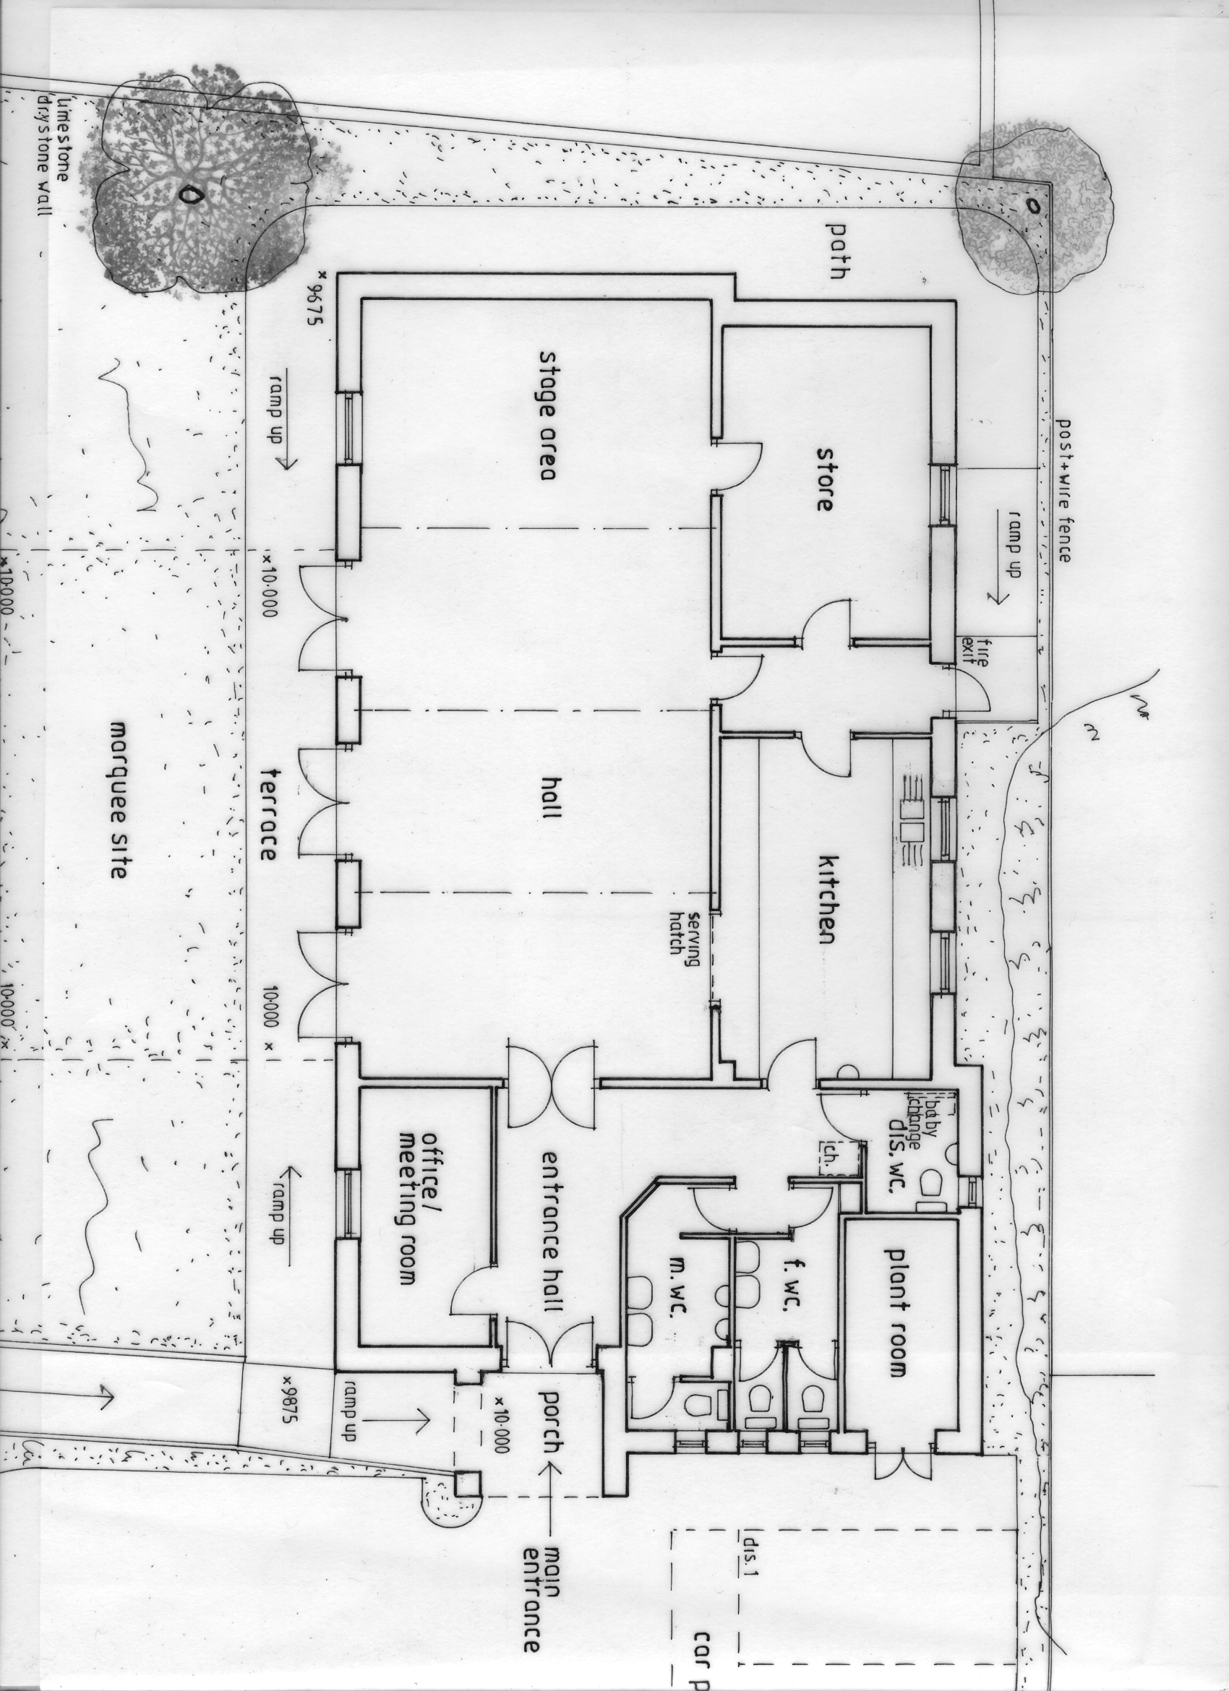 FOR KEY SEE PAGE 4
1
2
3
4
5
6.

7
8
9
10
11
12
13
14
16
15
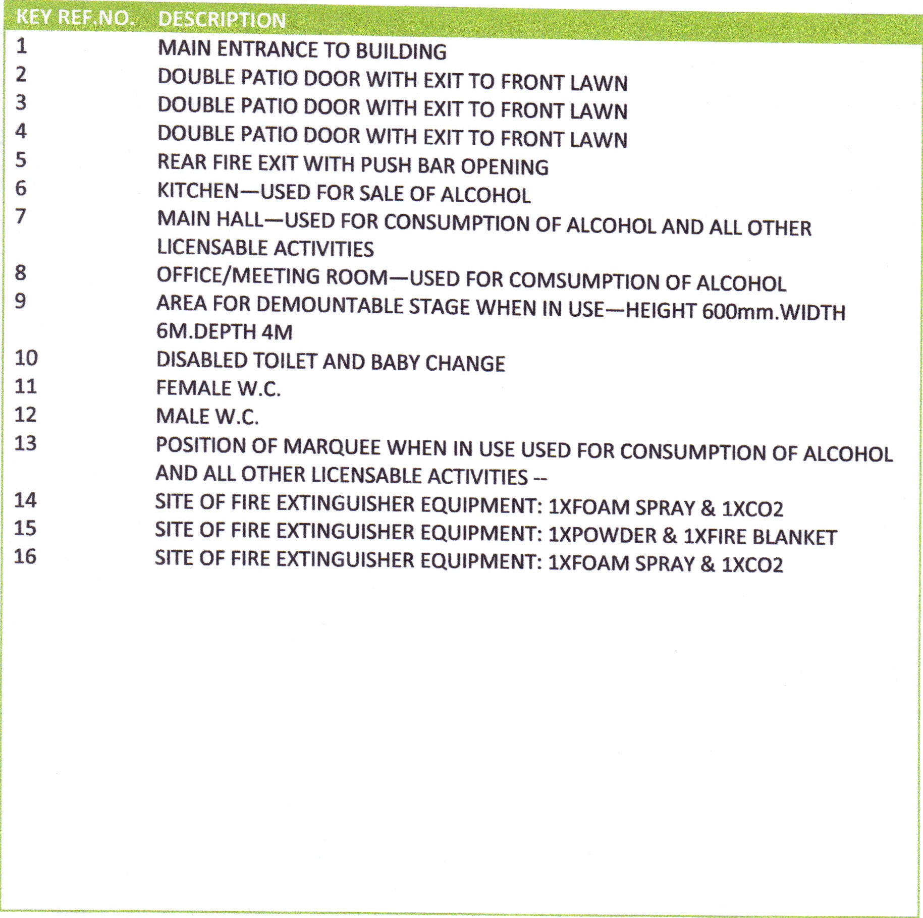
Part 3: Arrangements and Procedures
3.1 Licence The village hall has a Premises Licence authorising the following regulated entertainment and licensable activities at the times indicated:
Between the hours of:
a) The performance of plays (indoor & outdoor) 12.00 and 24.00
b) Exhibition of films (indoor) 12.00 and 24.00
c) The performance of live music (indoor & outdoor) 08.00 and 24.00
d) The playing of recorded music (indoor & outdoor) 08.00 and 24.00
e) The performance of dance (indoor & outdoor) 08.00 and 24.00
f) Entertainments similar to those in:
c), d) or e) (indoor & outdoor) 08.00 and 24.00
g) Provision of facilities for making music (indoor & outdoor) 08.00 and 24.00
h) Provision of facilities for dancing (indoor & outdoor) 08.00 and 24.00
i) Provision of facilities for entertainments similar to
those in: g) or h) (indoor & outdoor) 08.00 and 24.00
j) The sale of retail alcohol ON the premises ONLY 11.00 and 23.30
3.2 Fire Precautions and Checks
A map and key giving details of fire fighting equipment and fire exits are included at pages 3 and 4 of this document.
There is no public telephone in the village. Hirers are encouraged to bring mobile Phones with them.
The Assembly Point in case of fire is the car park at the rear of The Lathkil Hotel. Person/s on the management committee with responsibility for testing the fire alarms and for the fire risk assessment: Trish Renshaw, Roger Truscott, Jen Foxon.
Fire Brigade area office contact tel: 01298 608720.
Company hired to maintain and service fire safety equipment:
Name: K & K Fire Protection Engineers Ltd.
Address: Abbey Court, Darley Abbey Mills, Darley Abbey, Derby DE22 1DZ
Tel No.: 01332 341580
Location of service record: Handover File 3 in Office cupboard

List of Equipment and its location. For example:
Item | Test interval  (e.g. weekly/monthly/annual) | Location | Service Date
Residual Current Device | Every 5 years | Plant room | Next due 2022
Emergency Lighting | Weekly | Interior and exterior of building | Ongoing
Fire Exits | Weekly | See Plan on Page 3 | Ongoing
Fire fighting appliances | Annually | See Plan on Page 3 | Due June 2020
Portable Electrical Appliances. | Annually | Kitchen, Broom cupboard in Ladies Toilet, Loft space | Due June 2020
Electrical Installation | 5 years | Various | Due 2022

Procedure in case of accidents
The location of the nearest hospital Accident and Emergency/Casualty dept is:
Chesterfield Royal Hospital, Calow, Chesterfield, Derbys S44 5BL
Tel: 01246 277 271
The nearest defibrillator is located at:
The telephone box along Main Street, Over Haddon
The location and telephone no. for the nearest doctor’s surgery is:
Bakewell Medical Centre, Butts Road, Bakewell, Derbys
Tel: 01629 816636
The First Aid Box is located in:
In a marked cupboard in the Kitchen.
The person responsible for keeping this up to date is: Helen Head.
The accident book/forms are kept with the First Aid Box. This must be completed whenever an accident occurs.
Any accident must be reported to the member of the management committee responsible, who is: Jen Foxon.
The person responsible for completing RIDDOR forms and reporting accidents is: Jen Foxon.
The following major injuries or incidents must be reported on RIDDOR forms:
• fracture, other than to fingers, thumbs or toes
• amputation
• dislocation of the shoulder, hip, knee or spine
• loss of sight (temporary or permanent)
• any penetrating injury to the eye (including chemical)
• injury from electric shock/burn leading to unconsciousness or requiring resuscitation or admittance to hospital for more than 24 hours;
• any other injury leading to hypothermia, heat – induced illness or unconsciousness or requiring resuscitation or requiring admittance to hospital for more than 24 hours
• unconsciousness caused by asphyxia or exposure to harmful substance or biological agent
• acute illness requiring medical treatment or loss of consciousness arising from absorption of any substance by inhalation, ingestion or through skin
• acute illness requiring medical attention which may have resulted from a biological agent or its toxins or infected material.
Relevant examples of reportable dangerous occurrences include:
• electrical short circuit or overload causing fire or explosion
• collapse or partial collapse of a scaffold over 5m high
• unintended collapse of a building under construction or alteration, or of a wall or floor
• explosion or fire
Safety Rules
All hirers will be expected to read the whole of the hiring agreement and should sign the hiring form as evidence that they agree to the hiring conditions. All new hirers will also be given information/training by the booking secretary about safety procedures at the hall which they will be expected to follow (e.g. fire evacuation procedures, use of trolleys to move equipment, use of equipment) and will be shown the location of the accident book and health and safety file.
Over Haddon Village Hall Management Committee has carried out risk assessments, including those for hazardous substances and fire. Any hazards identified through the risk assessment and any procedures to be adopted in order to minimise risk have been identified. These are provided to hirers with the hiring agreement, so as to draw attention to them.
Contractors
The management committee will check with contractors (including self-employed persons) before they start work that:
• the contract is clear and understood by both the contractors and the committee
• the contractors are competent to carry out the work e.g. have appropriate qualifications, references, experience
• contractors have adequate public liability insurance cover
• contractors have seen the health and safety file and are aware of any hazards which might arise (e.g. electricity cables or gas pipes)
• contractors do not work alone on ladders at height (if necessary a volunteer should be present)
• contractors have their own health and safety policy for their staff
• the contractor knows which member of the committee is responsible for overseeing that their work is as asked and to a satisfactory standard
• any alterations or additions to the electrical installations or equipment must conform to the current regulations of the Institute of Electrical Engineers.
Insurance
Name and address of insurer: Allied Westminster (Insurance Services) Ltd, Allied House, Holgate Lane, Boston Spa LS23 6BN. Telephone no of insurer: 01937 845245 Policy No: VH/88/0047440/BS68641 Date of Renewal: 13th March annually. Any risks excluded or special conditions users should be aware of: NONE
Review of Health and Safety Policy
The management committee will review this policy annually. The next review is due in July 2020.
Committee members with responsibility for aspects of health and safety will report to the committee regularly, including any accidents, faults, misuse by hirers or other matters which could affect the health and safety of users or employees.

